


Report changes – Incorrect format in commits



Document Control Information
Document Information
Document Name | Report changes – incorrect format in commits
Project Name | Humana Salesforce DevOps
Client | Humana
Document Author | Regin Kanagappa
Document Version | 1.0
Document Status | Draft
Date Released | 11/14/2022
Document Edit History
Version | Date | Additions/Modifications | Prepared/Revised by
Document Review/Approval History
Date | Name | Organization/Title | Comments

Table of Contents
1. Report changes shows incorrect format on Commits 4
2. Workaround 5

Report changes shows incorrect format on Commits
When a user commits a report change, noticed incorrect format under the “Selected Metada” within metadata grid of a User Story. It is commiting with value "%2f" instead of the "/". Because of this incorrect format, the commit operation is not recognizing the change and throws an exception “No changes within this commit” and user is not able to commit the change inorder to deploy it.
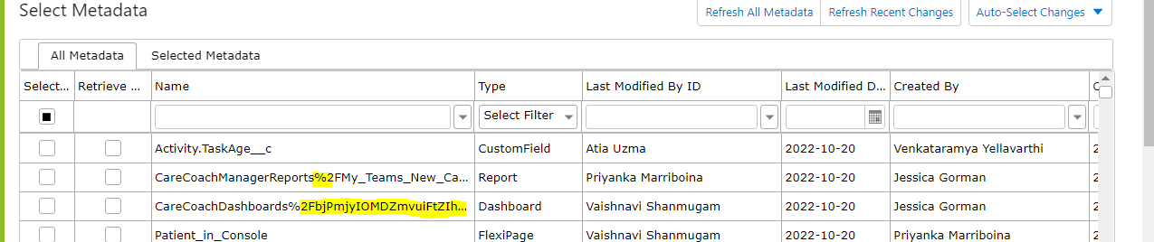

Workaround

- Click on “Refresh All Metadata". This operation update the metada with name with right formatting i.e, replaces "%2f" with "/".

